You are receiving this email as a member of the media.
If you wish to unsubscribe from future messages, please reply with UNSUBSCRIBE in the subject line.

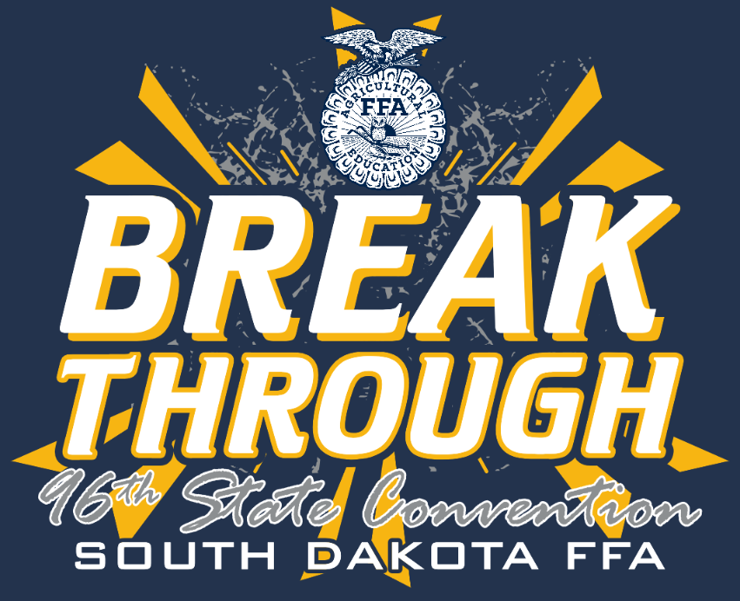
NEWS RELEASE

South Dakota FFA Association
Website: www.sdaged.org
Facebook: www.facebook.com/South.Dakota.FFA
Instagram: @sdffaassociation
For more information, contact:
Caroline Hansen
South Dakota Leadership and Program Manager
Caroline.hansen@sdaged.org

FOR IMMEDIATE RELEASE
April 19, 2024

Photos of Honorary State Degree Recipients: https://drive.google.com/drive/folders/17nTcCOfjU7csZE4CGGa1SLjd_msoHJPF?usp=sharing

Photos of Distinguished Service Recipients: https://drive.google.com/drive/folders/1aGwKKw293uwuui9y_3Hco9LseGqmFJE3?usp=sharing

Esteemed Supporters Honored at Convention
The South Dakota FFA Honorary State Degrees and Distinguished Service Awards were presented at the 95th Annual South Dakota State FFA Convention on April 17th, in Brookings, SD. These awards recognize outstanding contributions in support of the South Dakota FFA, acknowledging that ag leaders and industry are key in developing our future agriculture and community leaders.

The Distinguished Service Award is presented to businesses who have taken action to advocate for agriculture education on the state and local level to ensure our members have the best experience within our organization. The 2024 Distinguished Service Award recipients:
- Howard Bonneman, Brookings
- SDSU Meat Lab, Brookings
- Joe and Nicole Klein, White
- Lon and Mary Moeller. Brookings
- Dan and Susan Robbins, Elkton

Distinguished Service Award Caption:

Congratulations to the recipients of the 2024 Distinguished Service Award! Their dedication to advocating for agricultural education ensures our members have invaluable experiences within our organization. Front: Howard Bonnenman, Brookings; Joe and Nicole Klein, White; Lon Moeller, Brookings. Back: Adam Rhody, Rosie Nold, Christina Bakker, John Jaeger, SDSU Meat Lab, Brookings.

The Honorary State FFA Degree recognizes individuals who are helping to advance agricultural education and the FFA and who have rendered outstanding service to the organization with their time, talents and treasures. The following individuals received the Honorary State FFA Degree:
- Beth Mayrose-Kenkel
- Eric and Rechelle Dissing
- Dr. Barry Dunn
- Ashley Wiesen
- Dean Dunkelberger
- Tracy Chase
- Caroline Hansen
- Rob and Christy Zelinsky
- Tonya and Robert Feather
- DeLyssa Erickson
- David Kolb
- Crystal and Joey Larson
- Tammy and Dennis Rebelein
- Zana DeJong
- Condy Heidelberger
- Megan Harkless
- Jenny Behlings
- Danny Harris
- Genetie Hendrix
- Bailey Coats
- Lindsey Kaufman
- Karen Roudabush
- Shane Gross
- Alysha Kientopf
- Reed Johnson

###

Honorary State FFA Degree Caption:

Congratulations to the recipients of the Honorary State FFA Degree! Their commitment to advancing agricultural education and the FFA through their exceptional service, dedication, and support is truly commendable. Front: Caroline Hansen, Lindsey Kaufman, Karen Roudabush, Zana DeJong, Cindy Heidelberger, Beth Mayrose-Kenkel. Back: Alysha Kientopf, Shane Gross, Bailey Coats, Reed Johnson (picture #1) or Dr. Barry Dunn (picture #2), Dean Dunkelberger, Ashley Wiesen.

